Life Style Questionnaire

Name:

Please complete the attached questionnaire and indicate whether you would like any further support.

Alcohol Users Disorders Identification Test (AUDIT) C

 | Scoring System
Questions | 0 | 1 | 2 | 3 | 4 | Your Score
How often do you have a drink that contains alcohol? | Never | Monthly or Less | 2-4 per month times | 2-3 times per week | 4+ times per week
How many standard alcoholic drinks do you have on a typical day when you are drinking | 1 - 2 | 3 - 4 | 5 - 6 | 7 - 8 | 10+
How often do you have 6 or more standard drinks on one occasion? | Never | Less than monthly | Monthly | Weekly | Daily or almost Daily
Scoring: A total of 5+ indicates hazardous or harmful drinking

UNITS

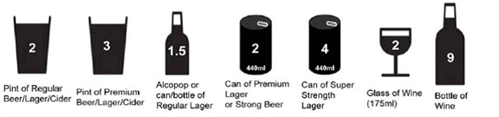
I am concerned about my level of drinking and would like to follow this up with some advice and support.

Please Circle YES NO

